Proposed Addendum to the
Town of Kinnickinnic Comprehensive Plan
May 21, 2023

Introduction
The Comprehensive Plan of the Town of Kinnickinnic was originally published on July 21, 2008. Part of the plan was an implementation schedule that summarized various activities and action items. This implementation schedule was reviewed by a town committee between October 2022 and March 2023, and proposed comments, corrections, and updates were forwarded to the Plan Commission and Town Board for consideration. All meetings were public, and citizen participation was welcomed as described in Town of Kinnickinnic Resolution 2005-3.

To better understand the intent of the elements in the implementation schedule, the committee reviewed each chapter of the Comprehensive Plan. Comments, corrections, and proposed updates were noted and are presented in this Addendum. The scope of the committee was not to edit, rewrite, or amend sections of the Comprehensive Plan, and the 2008 Comprehensive Plan was left in its original form. No attempt was made to verify or update the vast amount of data presented in the 2008 Comprehensive Plan.

For a better understanding or clarification of an implementation schedule element, it is recommended to refer to both this Addendum and the corresponding sections in the Comprehensive Plan.

The remainder of this document presents comments, corrections, and updates that pertain to the Comprehensive Plan and the implementation schedule. Where applicable, the original text is captured in a screenshot, followed by the proposed changes to the original text indicated in red.

The Town of Kinnickinnic adopted a Subdivision Ordinance on March 4th, 2014 and amended it on July 5th, 2022. Throughout the original Comprehensive Plan, the need for a Subdivision Ordinance had been identified. A Subdivision Ordinance is in place, and for readability, this Addendum does not refer to every occurrence in the Comprehensive Plan where the need for such ordinance had been expressed.

TABLE OF CONTENT
Document Changes by Sections | See Page
3.0 Housing Element  - 3.2 Assessment of Future Needs | 3
4.0 Transportation Element  - 4.2 Transportation Element | 4
5.0 Utilities and Community Facilities  - 5.1 Existing Conditions and Future Needs  - 5.2 Utilities and Community Facilities Goals, Objectives, and Policies | 6
6.0 Agriculture, Natural and Cultural Resources  - 6.1 Agricultural, Natural, and Cultural Resources Goals, Objectives, and Policies | 8
7.0 Economic Development | 9
8.0 Intergovernmental Cooperation  - 8.1 Existing Conditions | 11
9.0 Land Use | 11
Implementation Schedule | 13

Document Changes

SECTION: 3.0 HOUSING ELEMENT

  - Image of the Original Text, (Printed Page #15 and Electronic Page #18):
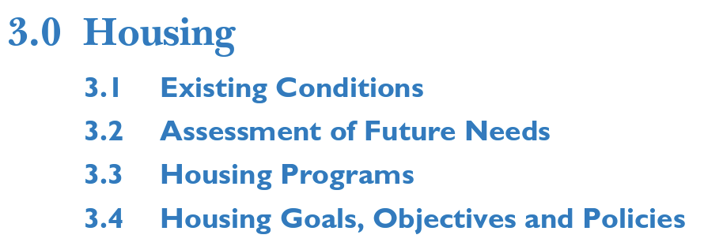
Comment:
- The original implementation schedule did not contain any elements regarding housing.

3.2 ASSESSMENT OF FUTURE NEEDS

  - Image of the Original Text, (Printed Page #15 and Electronic Page #19):
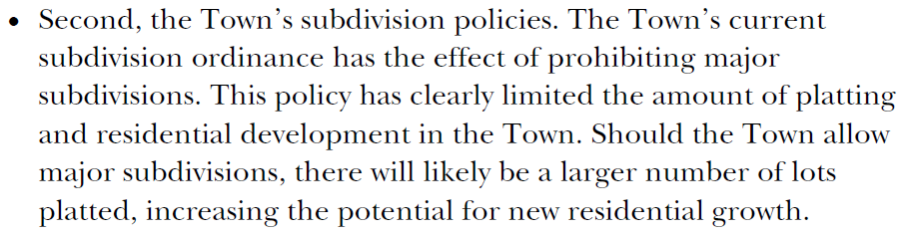
Update:
- The Town passed a Subdivision Ordinance in March 2014 and amended it in July 2022. This Subdivision Ordinance regulates and controls land divisions in the town, including major subdivisions.

Image of the Original Text, (Printed Page #15 and Electronic Page #19):
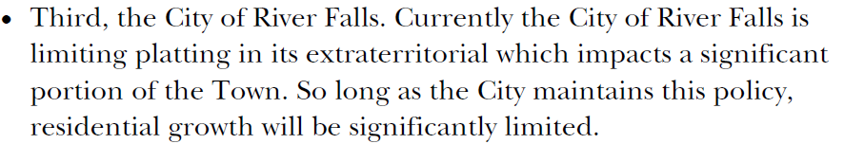
Update:
- The Town of Kinnickinnic and the City of River Falls entered a Cooperative Plan (also known as Cooperative Boundary Agreement) in January 2019. This Plan defines a much smaller area of the Town as Urban Reserve Area, abolishes the Extraterritorial Zone, and limits the City’s control of platting in the Town.

SECTION: 4.0 TRANSPORTATION ELEMENT

4.2 TRANSPORTATION ELEMENT

  - Image of the Original Text, (Print Page #19 and Electronic Page #22):
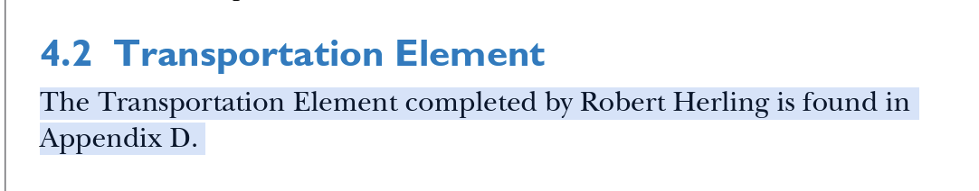

Correction:
- The correct reference is Appendix F and not Appendix D.

4.3 Other Transportation Plans and Programs

  - Image of the Original Text, (Print Page #19 and Electronic Page #22):
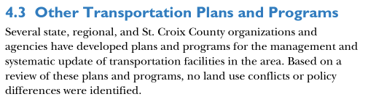
  - Update:
- The date for the Wisconsin State Highway Plan 2020 has passed. Information on new statewide transportation planning can be found in the Wisconsin Connections 2030 and Connect 2050 plans. Go to https://wisconsindot.gov/Pages/projects/multimodal/atp.aspx to find out more detailed information.

4.4 TRANSPORTATION GOALS, OBJECTIVES AND POLICIES

  - Image of the Original Text, (Printed Page #20 and Electronic Page #23):
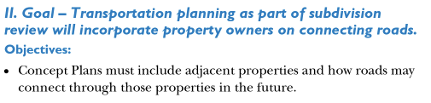
Comment:
- This requirement is applicable to minor and major subdivisions.

  - Image of the Original Text, (Printed Page #20 and Electronic Page #23):
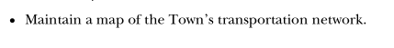
Comment:

- Every time a new road is built in the Town, it is added to the State’s Mileage Certification Map. This is a map of the transportation network that the Town maintains, with assistance of the State.
- Other maps of the Town’s transportation system have been created at the Town’s request, such as a Road Classification Map, but those maps are generally not maintained on a regular basis unless the Town requests/authorizes updates.

APPENDIX F - TRANSPORTATION WITHIN THE TOWN

  - Image of the Original Text, (Printed Page #6 of Appendix F and Electronic Page #158):
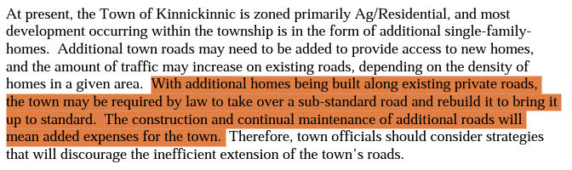
Comment:
- A road serving three or more lots must be designed and built to town standards and dedicated to the town. The town is not required to accept a sub-standard road and/or rebuild it to bring it up to standard. See Road and Driveway Ordinance for more detail.

Comment:
- Shoulder standards for town roads can be found in the Road and Driveway Ordinance. When a road is built or rebuilt, these standards are applied to determine the appropriate shoulder width.

APPENDIX F - SNOWMOBILES AND ATVS

  - Image of the Original Text, (Printed Page #16 of Appendix F and Electronic Page #168):
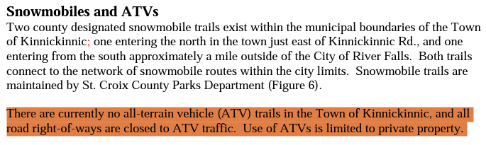
Update:
- All roads within the town of Kinnickinnic are designated ATV routes. For conditions on the use of these routes, see ATV Route Ordinance.

SECTION: 5.0 UTILITIES AND COMMUNITY FACILITIES

5.1 EXISTING CONDITIONS AND FUTURE NEEDS

  - Image of the Original Text, (Print Page #22 and Electronic Page #25):
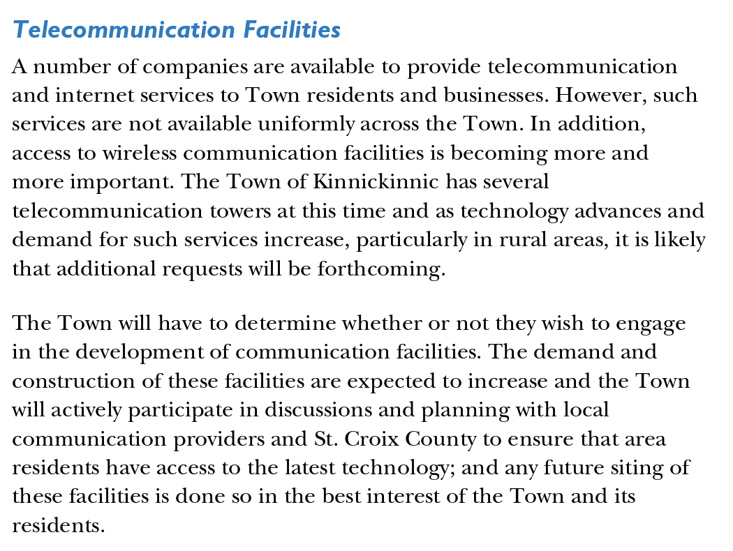
  - Update:
- The town partnered with SwiftCurrent, a subsidiary of Pierce Pepin Cooperative Services, to bring broadband to Kinnickinnic. Completion of the project, made possible by county and state grants, is planned for the end of 2023. Connections to individual residences could spill over into 2024.

  - Image of the Original Text, (Printed Page #25 and Electronic Page #28):
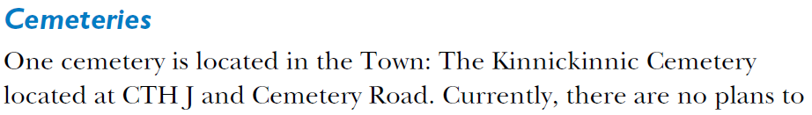
  - Correction:
- The cemetery is located at CTH J and Old Cemetery Road.

  - Image of the Original Text, (Printed Page #25 and Electronic Page #28):
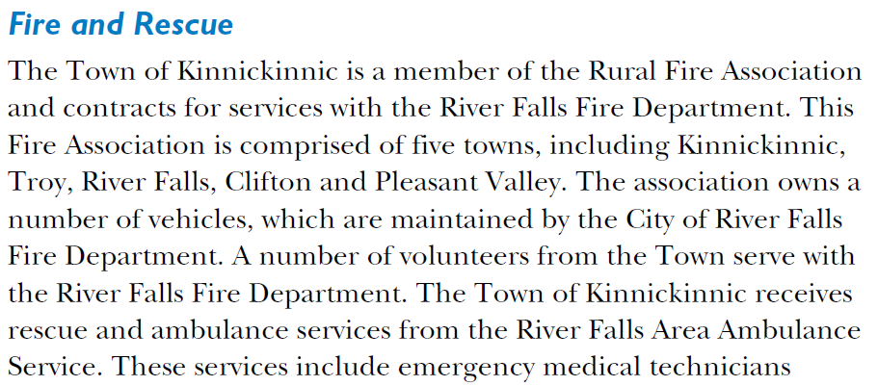
Update:
- The Rural Fire Association does not own fire vehicles nor any other firefighting equipment anymore. Ambulance service is now provided by Allina Health Emergency Medical Services.

5.2 UTILITIES AND COMMUNITY FACILITIES GOALS, OBJECTIVES, AND POLICIES

  - Image of the Original Text, (Printed Page #27 and Electronic Page #30):
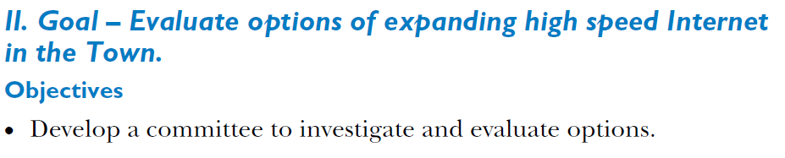
  - Update:
- This item is complete. A broadband project is currently being executed in the Town.

  - Image of the Original Text, (Printed Page #27 and Electronic Page #30):
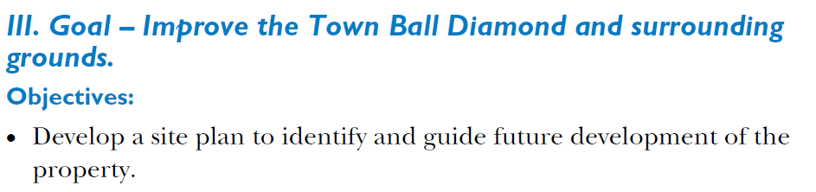
Comment:
- The ball field is mowed, and the back fence maintained to provide an opportunity for the public to play ball. Other improvements of the town property, e. g. the recycling center, are reviewed as a need is identified.

SECTION: 6.0 AGRICULTURE, NATURAL AND CULTURAL RESOURCES
6.1 AGRICULTURAL, NATURAL, AND CULTURAL RESOURCES GOALS, OBJECTIVES, AND POLICIES
Image of the Original Text, (Printed Page #29 and Electronic Page #32):
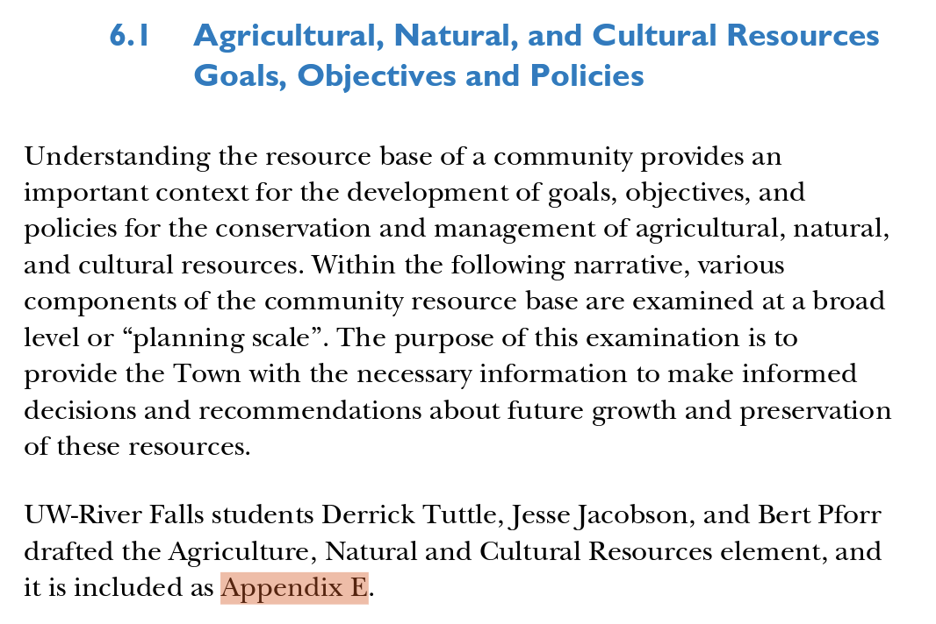
  - Correction:
- The correct reference is Appendix G and not Appendix E.

  - Image of the Original Text, (Printed Page #30 and Electronic Page #33):
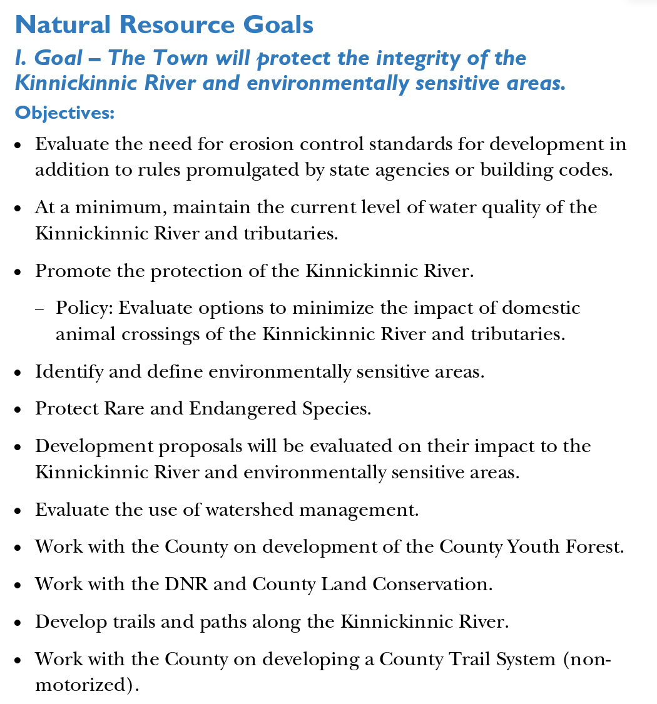
  - Comment:
- The Town does not have the required expertise and technical means to manage many of the agricultural, natural, and cultural resources, relies on county and state support, and contracts with an engineering firm for technical support, as needed.
- While the Town promotes protection of the Kinnickinnic River, it does not have the means to have a comprehensive monitoring program in place and relies on state, county, and private resources for support (e.g. WI DNR; Kinnickinnic River Land Trust).
- The townhall property is maintained for safe use, including the townhall, the recycling facility, and the baseball field.

SECTION: 7.0 ECONOMIC DEVELOPMENT

  - Image of the Original Text, (Printed Page #32 and Electronic Page #35):
  - 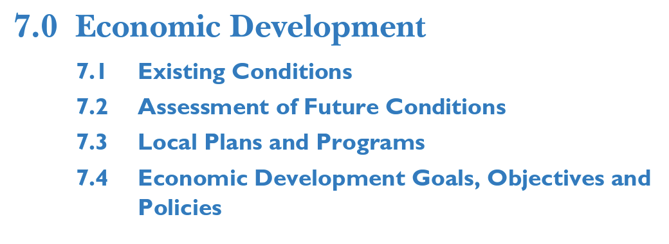
  - Comment:
- Since the original Comprehensive Plan was written and approved in 2008, the internet-based economy has developed and expanded tremendously. An estimate in IBISWorld (published August 26, 2022), estimates that the percentage of business conducted online in 2023 will be 28%, with an annualized growth rate from 2018 to 2023 of 3.6%. The economic impact this trend may have on the Town of Kinnickinnic is difficult to estimate since business can be conducted from a home office that has no visibility to the town nor does it have an environmental impact different from private, non-commercial internet use. The volume of this online business activity can be expected to increase for the foreseeable future and will further be enabled by broadband internet becoming available in the town.

Figure 7.1: Downloaded from https://www.ibisworld.com/us/bed/percentage-of-business-conducted-online/88090/
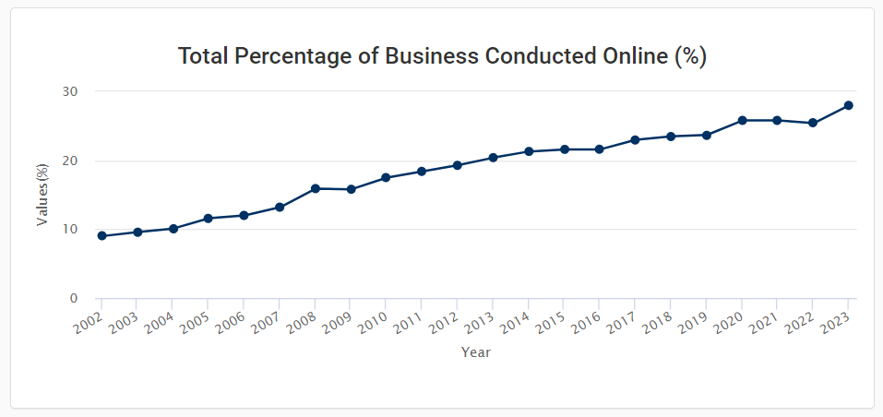
- The percentage of business conducted online represents the increasing use of the internet by consumers and businesses for services they historically demanded in-person (e.g., the use of email instead of written letters or the use of video streaming services instead of DVDs). IBISWorld uses the revenue generated electronically in the manufacturing, wholesaling, retail, and services sectors as a percentage of total revenue as a proxy for this effect. Data is sourced from the United States Census Bureau.

SECTION: 8.0 INTERGOVERNMENTAL COOPERATION

8.1 EXISTING CONDITIONS
Intergovernmental Plans, Agreements, and Relationships
  - Image of the Original Text, (Printed Page #36 and Electronic Page #39):
  - 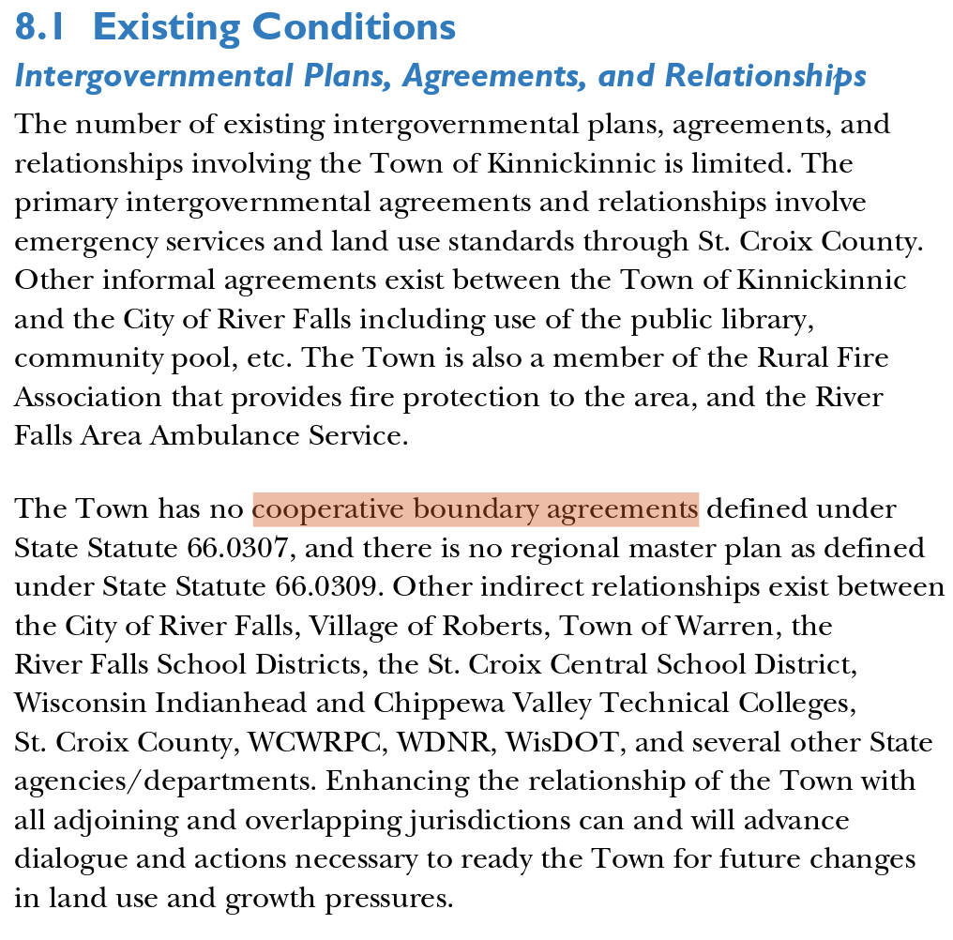
  - Update:
- The City of River Falls and the Town of Kinnickinnic entered into a Cooperative Boundary Agreement (Resolution 2019-1, adopted 03 Jan 2019).

Comment:
- The Town of Kinnickinnic continues to follow County zoning. River Falls Area Ambulance Service was replaced by Allina Health Ambulance Service.

SECTION: 9.0 LAND USE

9.3 Land Use Summary

  - Image of the Original Text, (Printed Page #51 and Electronic Page #54):
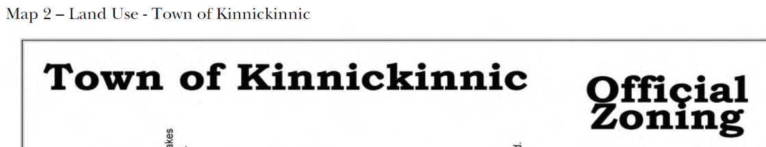

  - Comment:
- The zoning map on page 51 of the Comprehensive Plan is outdated. A current zoning map can be found at the town hall. St. Croix County has zoning information on their website (see St. Croix CO.M.P.A.S. – St. Croix County Mapping Platform and Services).

  - Image of the Original Text, (Printed Page #58 and Electronic Page #61):
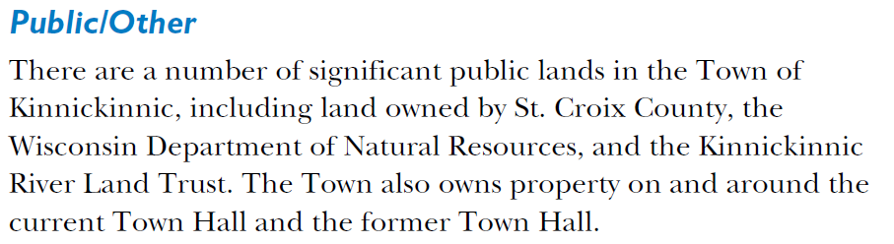
  - Update:
- The land around the former town hall is no longer owned by the town and was transferred back to the previous owner.

  - Image of the Original Text, (Printed Page #60-62, and 65; Electronic Page #63-65, and 68):
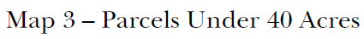

  - Update:
- The maps on these pages are no longer current. Up-to-date land information can be found on the St. Croix County website, e. g. using the WG Xtreme system to get detailed parcel information.

IMPLEMENTATION SCHEDULE
  - Proposed changes shown in red.
  - OG = On Going
  - TBD = To Be Determined
  - CD = Currently Doing
  - C = Complete
Section | Target Date
Transportation Implementation Schedule
Objectives: Maintain a map of the Town’s transportation network | C
Policies: Amend the Town Road Standard to include wide shoulders | C
Objectives: Work with the County in planning recreational trails | C
Policies: Evaluate options on improving Liberty Road | C
Policies: Use the Town’s Road and Driveway Ordinance to adequately address road construction standards | OG
Objectives: Negotiate with the City of River Falls to pay for improvements and maintenance needed for those roads that may be impacted by city traffic. Initial priority roads for consideration are Liberty, Quarry, and Chapman Roads | C
Objectives: Utilize the subdivision ordinance to help ensure that development pays the costs of road improvements required by the development.  Comment: Road design standards can be found in the Road and Driveway Ordinance. Roads constructed as part of a new subdivision need to meet the requirements of the Road and Driveway Ordinance. Details will be addressed in a developer’s agreement. | OG
Policies: The town conducts a spring and a fall road review to evaluate road conditions and maintenance needs. | CD/OG
Utilities and Community Facilities Implementation Schedule
Goal – Encourage the use of alternative energy sources in future
developments that are consistent with the goals of a rural community
Objectives: Develop information on available funding for  alternative energy to promote these concepts to current and  future residents  Comment: The town does not have the resources to maintain information on available funding for alternative energy. | C
Policies: Distribute information on alternative energy  options through the Town website, mailings and postings | C
Objectives: Evaluate the need to regulate alternative energy  production to maintain the rural character of the Town | C
Goal: Evaluate options of expanding high speed Internet in the Town
Objectives: Develop a committee to investigate and evaluate options.  Comment: This work was completed in 2021, and the town partnered with SwiftCurrent to bring broadband to Kinnickinnic. Scheduled completion is end of 2023. | C
Agricultural, Natural, and Cultural Resources Implementation Schedule
The Town will work with the County to maintain zoning that supports farming. | C
Identify and define environmentally sensitive areas.  Comment: The town does not have the appropriate resources to address this topic. County and State agencies are already managing environmentally sensitive areas. | C
Evaluate the use of watershed management.  Comment: The town does not have the appropriate resources to address this topic. County and State agencies are already managing the watershed, and the Kinnickinnic River Land Trust is also instrumental in this effort. | OG
Develop trails and paths along the Kinnickinnic.  Comment: The Kinnickinnic River Land Trust is instrumental in this effort. | OG
Work with the County on developing a County Trail System (non-motorized)  Comment: Town Roads are open to bicycle and pedestrian traffic, but no dedicated bike lanes or pedestrian trails are available at this time due to road width limitations. | OG
Economic Development
No elements identified in the original implementation schedule.
Intergovernmental Cooperation Implementation Schedule
Policies: Identify means to solicit the City of River Falls to pay for road improvements required by traffic being generated by City residents  Comment: The Cooperative Boundary Agreement created a much smaller Urban Reserve Area with fewer road miles. There is currently no mechanism to charge the town for citizens driving on town roads. | C
Policies: Develop intergovernmental agreements with other local units of government that implement the goals, objectives, and policies of this plan  Comment: A Cooperative Boundary Agreement between the Town and the City of River Falls exists. | C
Land Use Implementation Schedule
Objectives: Use common sewer where appropriate | OG
Policies: The Town will develop a policy on managing  common sewer systems to see that such systems are operated  in a manner that helps ensure their environmental  effectiveness and meets financial obligations.  Comment: Requirements for common wastewater treatment systems can be found in the Town’s Subdivision Ordinance and the St. Croix County’s Ordinance Chapter 15 – Zoning. The Zoning ordinance requires zoning R3 – Residential District, which the Town does not have at the time of this comment. | C
Objectives: Limit/regulate (ILSLOs) Intensive Large Scale Livestock Operations are regulated by county zoning. See St. Croix County Ordinance Chapter 15 - Zoning | OG
Policies: The Town will evaluate the creation and implementation of a dark night sky ordinance.  Comment: The Town’s Planning Commission determined on 5/17/23 that a dark night sky ordinance was no needed at this time. | C
Objectives: Subdivision ordinances will be drafted to provide  incentives for accomplishing the goals of this Plan.  Comment: A Subdivision Ordinance was first passed in 2014 and restated in 2022. | C
Policies: The Town will amend its ordinances to require development proposals to be submitted in a format that allows posting on the Town website for download and review by residents and land owners. | C

Document Revision History
March 22, 2023 V. 1.0 First Draft Sent to Plan Commission and Town Board by town clerk
May 17, 2023 V. 1.0 Plan Commission Document reviewed and discussed; comments and
clarifications received from Plan Commission.
May 21, 2023 V. 2.0 Updated Draft Comments and clarifications from 5/17/23 included in updated
draft.

